Insert your name, centre number and candidate number into the header above.
Save this evidence document as evidence_ followed by your centre number_ candidate number. For example: evidence_ zz999_9999.doc
Screenshots or program listings must be copied into appropriate cells in the following tables.
Examiners must be able to read the contents including any screenshots without the use of a magnifying glass. Answers that are not readable or missing will not be awarded any marks.
Save this evidence document at regular intervals, for example, every 10 minutes.
Question 1
Part 1(a)
global DataStored, NumberItems
DataStored = []
NumberItems = 0

Part 1(b)
def Initialize():
n = -1
while(n < 1 or n > 20):
n = int(input("Enter how many numbers to enter, between 1 and 20 inclusive:"))
for i in range(n):
DataStored[i] = int(input())

Part 1(c)(i)
def main():
global NumberItems, DataStored
Initialize()
for i in range(len(DataStored)):
print(DataStored[i])

if __name__ == "__main__":
main()

Part 1(c)(ii)
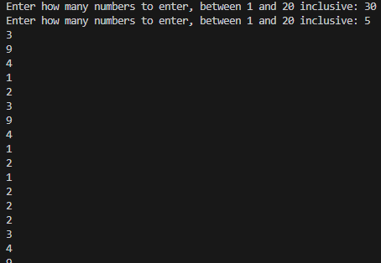

Part 1(d)(i)
def BubbleSort():
global DataStored
flag = False
while not flag:
flag = True
for i in range(len(DataStored) - 1):
if DataStored[i] > DataStored[i + 1]:
flag = False
DataStored[i], DataStored[i + 1] = DataStored[i + 1], DataStored[i]

Part 1(d)(ii)
def main():
global NumberItems, DataStored
Initialize()
for i in range(len(DataStored)):
print(DataStored[i])
BubbleSort()
for i in range(len(DataStored)):
print(DataStored[i])
print(BinarySearch(int(input("Enter the number to find: "))))

if __name__ == "__main__":
main()

Part 1(d)(iii)
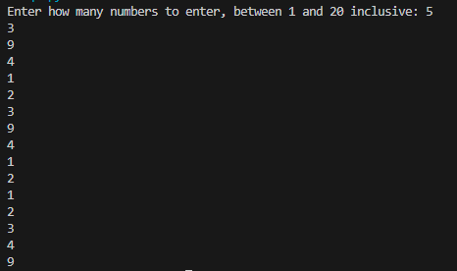

Part 1(e)(i)
def BinarySearch(DataToFind):
global DataStored
left = 0
right = len(DataStored) - 1
while (right > left + 1):
if DataStored[(left + right) // 2] == DataToFind:
return (left + right) // 2
elif DataStored[(left + right) // 2] > DataToFind:
right = (left + right) // 2
else:
left = (left + right) // 2
return -1

Part 1(e)(ii)
def main():
global NumberItems, DataStored
Initialize()
for i in range(len(DataStored)):
print(DataStored[i])
BubbleSort()
for i in range(len(DataStored)):
print(DataStored[i])
print(BinarySearch(int(input("Enter the number to find: "))))

if __name__ == "__main__":
main()

Part 1(e)(iii)
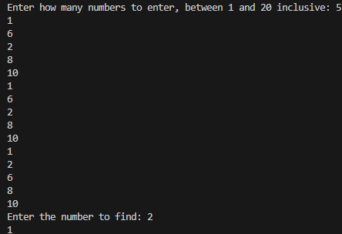
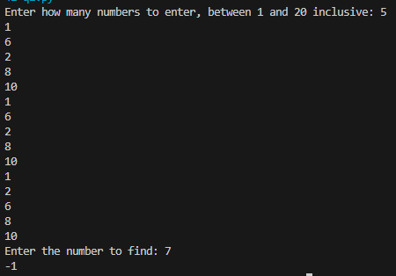

Question 2
Part 2(a)(i)
class Tree:
def __init__(self, tn, hg, mh, mw, eg):
self.__TreeName = tn #string
self.__HeightGrowth = hg #integer
self.__MaxHeight = mh #integer
self.__MaxWidth = mw #integer
self.__EverGreen = eg #string

Part 2(a)(ii)
def GetTreeName(self):
return self.__TreeName
def GetGrowth(self):
return self.__HeightGrowth
def GetMaxHeight(self):
return self.__MaxHeight
def GetMaxWidth(self):
return self.__MaxWidth
def GetEvergreen(self):
return self.__EverGreen

Part 2(b)
def ReadData():
arr = [] #array of type Tree
try:
with open("Trees.txt", "r", encoding = "utf-8") as f:
for line in f:
lst = line.split(",")
arr.append(Tree(lst[0].strip(), int(lst[1]), int(lst[2]), int(lst[3]), lst[4].strip()))
return arr
except FileNotFoundError:
print("File does not exist!")

Part 2(c)
def PrintTrees(a):
print(f"{a.GetTreeName()} has a maximum height {a.GetMaxHeight()} a maximum width {a.GetMaxWidth()} and grows {a.GetGrowth()} cm a year.", end = " ")
if a.GetEvergreen() == "Yes":
print("It does not lose its leaves.")
else:
print("It loses its leaves each year.")

Part 2(d)(i)
def main():
arr = ReadData()
PrintTrees(arr[0])

if __name__ == "__main__":
main()

Part 2(d)(ii)

Part 2(e)(i)
def ChooseTree(arr):
h = int(input("Enter maximum height required: "))
w = int(input("Enter maximum width required: "))
e = input("Enter wheter evergreen or not, yes or no: ")
global res
res = []
for i in range(len(arr)):
if arr[i].GetMaxHeight <= h and arr[i].GetMaxWidth <= w and arr[i].GetEvergreen().casefold() == e.casefold():
res.append(arr[i])
if len(res) == 0:
print("No trees meet the requirement.")
else:
for i in range(len(res)):
PrintTrees(res[i])

Part 2(e)(ii)
def ChooseTree(arr):
h = int(input("Enter maximum height required: "))
w = int(input("Enter maximum width required: "))
e = input("Enter wheter evergreen or not, yes or no: ")
global res
res = []
for i in range(len(arr)):
if arr[i].GetMaxHeight() <= h and arr[i].GetMaxWidth() <= w and arr[i].GetEvergreen().casefold() == e.casefold():
res.append(arr[i])
print(len(res))
if len(res) == 0:
print("No trees meet the requirement.")
else:
for i in range(len(res)):
PrintTrees(res[i])
name = input("Enter the name of the tree you want to buy: ")
height = int(input("Enter the height of the tree when you bought: "))
for i in range(len(res)):
if res[i].GetTreeName().casefold() == name.casefold():
print(f"The tree will take {(res[i].GetMaxHeight() - height) / res[i].GetGrowth()} years to reach its maximum height of {res[i].GetMaxHeight()} cm.")

Part 2(e)(iii)
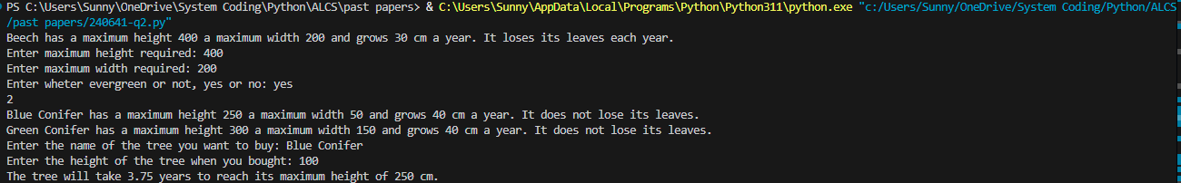

Question 3
Part 3(a)
global QueueData, QueueHead, QueueTail
QueueHead = -1
QueueTail = -1
QueueData = [""] * 20

Part 3(b)
def Enqueue(item):
global QueueData, QueueHead, QueueTail
if QueueTail >= 19:
return False
else:
QueueTail += 1
QueueData[QueueTail] = item
return True

Part 3(c)
def Dequeue():
global QueueData, QueueHead, QueueTail
if QueueTail == QueueHead:
return "false"
else:
tmp = QueueData[QueueHead]
QueueHead += 1
return tmp

Part 3(d)(i)
def StoreItems():
cnt = 10
for i in range(10):
n = input("Enter a 7-character string: ")
c = n[6]
if c == "X": c = "10"
t = int(n[:6])
sum = 0
while t != 0:
sum += t % 10 * 3
t //= 10
sum += t % 10
t //= 10
if sum // 10 == int(c):
cnt -= 1
Enqueue(n[:6])
print(f"There were {cnt} invalid items.")

Part 3(d)(ii)
def main():
global QueueData, QueueHead, QueueTail
QueueHead = 0
StoreItems()
a = Dequeue()
if a == "false":
print("The queue is empty.")
else:
print(a)

if __name__ == "__main__":
main()

Part 3(d)(iii)
